**AWS Secrets Manager**

TASK . Storing a RDS credentials and enable rotate secret keys

1. Create a secret key and enable rotation for every 4 hours.

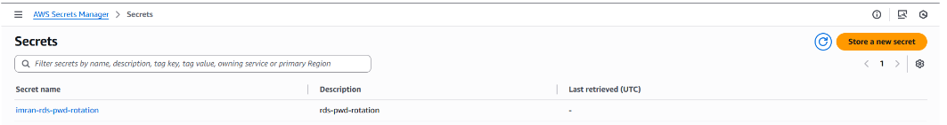

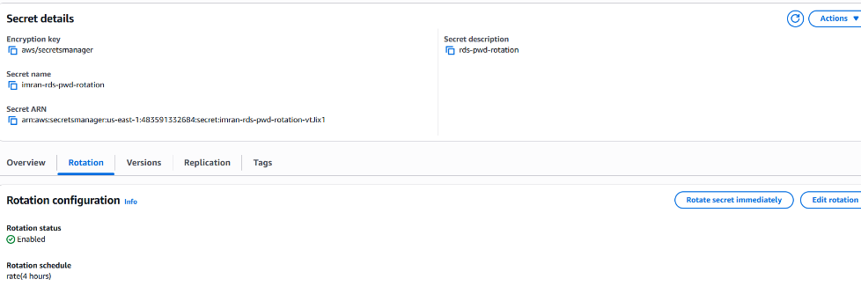

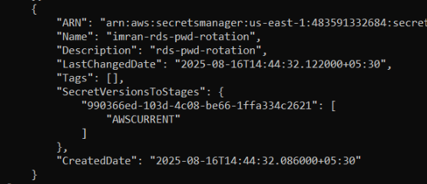

After 4 hrs pwd will change